**DS PSI-PC* Synthèse type CCP**

**Mars 2025**

**durée 3 heures**

Rédiger en anglais et en **400** mots une synthèse des documents proposés, qui devra obligatoirement comporter un titre. Indiquer avec précision, à la fin du travail, le nombre de mots utilisés (titre inclus) ; vous aurez soin d’en faciliter la vérification en mettant un trait vertical tous les vingt mots. Un écart de 10% en plus ou en moins sera toléré.

Vous n’indiquerez en introduction que **la source et la date de chaque document**. Vous pourrez ensuite, dans le corps de la synthèse, faire référence à ces documents par ‘doc. 1’, ‘doc.2’,  … , après avoir pris soin de préciser dans l’introduction à quel document correspondent ces "doc.1’’, etc.

L’ordre dans lequel se présentent les documents est aléatoire et tous les documents sont d’égale importance.

Ce sujet comporte les 4 documents suivants :

- **Document 1** – Millennials were told buying property would set us up for life – it was a lie ( extrait et adapté de *Metro*, Natalie Morris, November 2022)

- **Document 2** – Sunak and Starmer are obsessed with home ownership. Neither seems to want to fix the housing crisis (extrait et adapté de *The Guardian*, Kieran Yates, May 2023)

**- Document 3** – ‘One of the best places to live in Britain’ declares housing crisis as rents spiral out of control, (extrait et adapté de *The Independent, August* 2023)

- **Document 4** - A photograph from *The Guardian*, 26 August 2015.

*☞ Merci de penser à laisser une marge confortable pour la correction*

**Document 1**

**Millennials were told buying property would set us up for life – it was a lie** by Natalie Morris in *Metro*, 13 Nov 2022

Buying a property has always been high on my list of goals for adulthood. Like most Millennials, I was taught that homeownership is a marker of success, a symbol that I was doing things ‘properly’, and I had this message instilled very early in my adult life. Older relatives and colleagues would tell me that renting was ‘pouring money down the drain’, that bricks and mortar were the safest and most sensible investment. (...)

Last year, at age 32, I finally did it. My partner and I bought our first flat – a two-bed with a shared garden that we absolutely adore – and it felt like a huge step. Finally, I’m a homeowner. Everything should be simple, easier, better, from here on in.

But, when it comes to buying property, Millennials like me have been sold a lie. The promised land of homeownership is no longer the green and fruitful utopia it once was. With interest rates rocketing, house prices decreasing, and everyone being squeezed by the cost of living crisis, it feels like the worst moment in decades to own property.

I mean, of course it does. We Millennials simply cannot catch a break. Dubbed ‘generation rent’, most of us spent our 20s paying other people’s mortgages* while being mocked and derided for it by a generation of people who bought property when it was 14 times more affordable than today.

Just last week, the cost of an average two-year fixed mortgage was 6.45%, while a five-year deal was 6.28%, according to Moneyfacts data. A little over a year ago, it was possible to get a fixed deal at under 1% for two or five years.

It won’t be the people with the highest incomes or those who bought their homes decades ago who will feel the brunt of this crisis. It will be felt by the people who have recently clawed their way onto the property ladder, those who are in the earlier stages of their careers and typically have less disposable income.

The predicted plunge in UK property prices next year is likely to leave almost a fifth of young homeowners living in low or negative equity, meaning their house is worth less than their mortgage amount, according to data from the Resolution Foundation. And don’t get excited if you think a crash in house prices will mean you can finally get on the property ladder. Lloyd’s Bank has modelled a worst-case scenario of 18% price falls, but even then, data says that almost three-quarters of young families would not have the funds to purchase a house.

Sadly, this is nothing new for Millennials. We have become painfully accustomed to getting the raw end of the deal. We are the generation who graduated into a recession, we have been saddled with more student debt than our parents were, and we are less well-off than the generation before us. (...)

Most people I know, particularly in London, have only managed to get on the property ladder with significant help from parents. My partner and I were able to buy our London home because my dad died and I received money from an insurance policy. I certainly wouldn’t call myself ‘lucky’ in these circumstances, but I know we are in an incredibly privileged position to own property, and to be able to stay in the city where we both work and have built our lives.

There are still lots of benefits to owning your own place. (...) But what’s different now is that instead of sitting back and watching your investment increase in value exponentially – like our parents’ generation did – we are now facing possible depreciations, negative equity, and disastrous mortgage hikes that are set to tip hundreds of thousands of people into poverty. (...)

As scary as things look for those of us with mortgages, things are even worse for renters who will be forced to shoulder the burden of their landlord’s increasing costs. Rental prices are going up every year, most recently by a fifth, and the number of available rental properties is dwindling, pushing people into ever more precarious living situations.

We are witnessing the real-life impacts of a housing market that has been built on unsustainable growth, and a culture that views property as an asset more than as a home.

We are doing our best to make our flat feel like our home. But no amount of Pinterest-worthy picture galleries or brightly painted feature walls can insulate us from the undercurrent of fear over what will happen when our fixed- term mortgage runs out.

*A mortgage : *un prêt immobilier*

**Document 2**

**Sunak and Starmer are obsessed with home ownership. Neither seems to want to fix the housing crisis**  Editorial by Kieran Yates, in *The Guardian*, 2 May 2023

Britain is obsessed with home ownership. This might date back to our history of land ownership, class and colonial exploit but the fixation lives on, thanks in no small part to Thatcher’s introduction of the right to buy in 1980.

This weekend, both parties made their bids to reckon with the housing crisis, and both leaders, predictably, zeroed in on ownership. The Tories have for years declared they would transform “generation rent” into “generation buy” and Rishi Sunak is now considering bringing back Help to Buy – a 2013 Tory policy that ended last year – to win votes at the next election. He also recently announced he would scrap the house-building target of 300,000 every year in England, displaying a wilful ignorance of what is actually needed to plug the housing deficit. House-building alone won’t solve the crisis, but it will hugely contribute to some of the most urgent needs in this country – namely the 1.3 million people on English council house waiting lists in need of social rented homes, many of whom are privately renting and sliding into poverty. (Meanwhile, the homes available to rent in the UK fell by a third over the past 18 months.)

Starmer was no more inspirational, promising that Labour would be the “party of home ownership”. Like the Tories, he appears to be obsessed with promising to get people on to the housing ladder – as if we can simply purchase our way out of a failing economy. This simply won’t happen for people who are staring down the barrel of wage stagnation and climbing debt.(...)

Housing is now a public health emergency in Britain, but there has been little mention by either party of accessing legal aid for disrepair claims, Awaab’s law which focuses on mould* (which affects more than a fifth of UK homes) and or Ella’s law on clean air – all crucial omissions. The sooner both parties recognise that housing is an intersectional crisis that has an impact on the NHS (poor housing costs the NHS £1.4bn a year) and is connected to historical wage freezes and austerity, the sooner we can understand the state of housing need in Britain and have true conversations about what is needed at scale.

Labour has provided glimmers of light, but they do not go far enough. Putting the renters charter firmly on the agenda, and reinstating building targets, is a good starting point. But alongside the discussion around housebuilding, we urgently need renewed emphasis on the quality of new homes that are built.

We need to think about how we make good quality rental homes in the long term and enact rent stabilisation ; listen to campaigners and ethical architects to update our housing stock – the oldest in Europe. (...)

Ultimately, despite their announcements this weekend, neither party has given housing its due prominence. Housing does not feature in Starmer’s five missions for a “better Britain” and Tory housing minister turnover (five in the last year) does not inspire confidence.

*mould = *moisissure*

**Document 3**

**‘One of the best places to live in Britain’ declares housing crisis as rents spiral out of control,** *The Independent*, 14 August 2023

A town in Somerset has officially declared a housing crisis as renting costs surge across the UK. Frome, a picturesque town near the Mendip Hills boasts winding streets full of independent shops, a bustling local market and lush countryside. It has been named one of the ‘best places to live in Britain’ by *The Times,* but the historic, small-town charm comes at a steep price. The average rent in Frome is now £1,499 a month, the kind of eye-watering prices you might expect in the capital not a parish with a population of less than 30,000 people.

Frome is the third town in the country to announce a housing crisis after South Hams in Devon and Leicester. “Rents have skyrocketed and that is pushing out local people who have been here all their lives,” councillor Polly Lamb told *the BBC*. Ms Lamb said there are 600 families on the official council list who are waiting to be housed. Only 50 have found a place to live so far this year.

The problem is exacerbated by commercial developers building “large, expensive family homes” - but the area “urgently” needs social housing, she said. Frome locals are struggling to find homes to rent in the bustling town

Local artist Summer Auty told t*he BBC* she “can’t afford anything in Frome” so she lives in her van. The 24-year-old said she found single rooms available for £500 a month or over a thousand for “just a small flat”.

In July, property website Rightmove said the average rent being asked outside London has risen to £1,231 per month, while the asking rent for new tenants in London is at a record £2,567. The figures, for the second quarter of this year, are the highest in Rightmove’s 12-year history of covering the issue.

**Document 4 A photograph from *The Guardian*, 26 August 2015**

*The King family of Milton Keynes receive the deeds* to their council house from the Prime Minister, Margaret Thatcher in 1979.The Tories sold thousands of ex-council houses under the Right to Buy Act in the 1980s.*

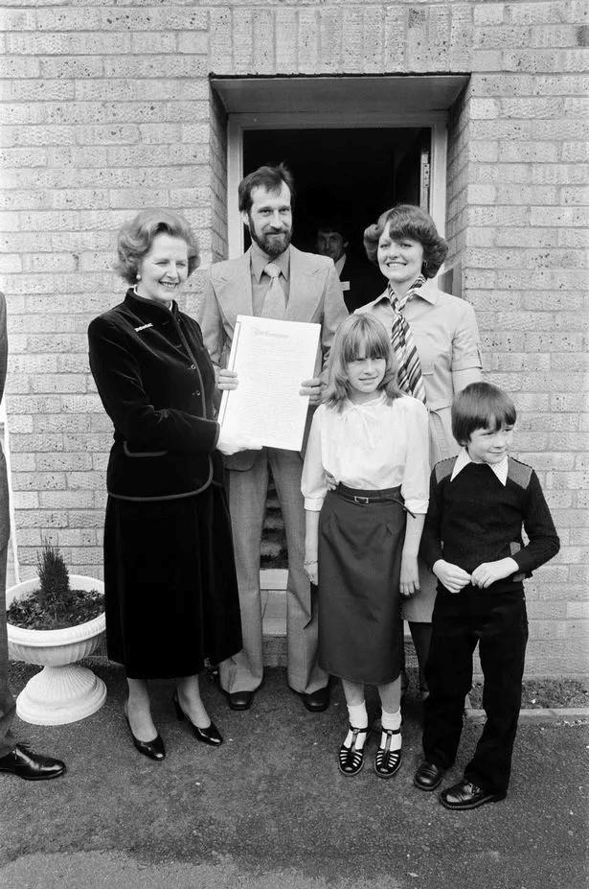

* deeds = *acte de vente*